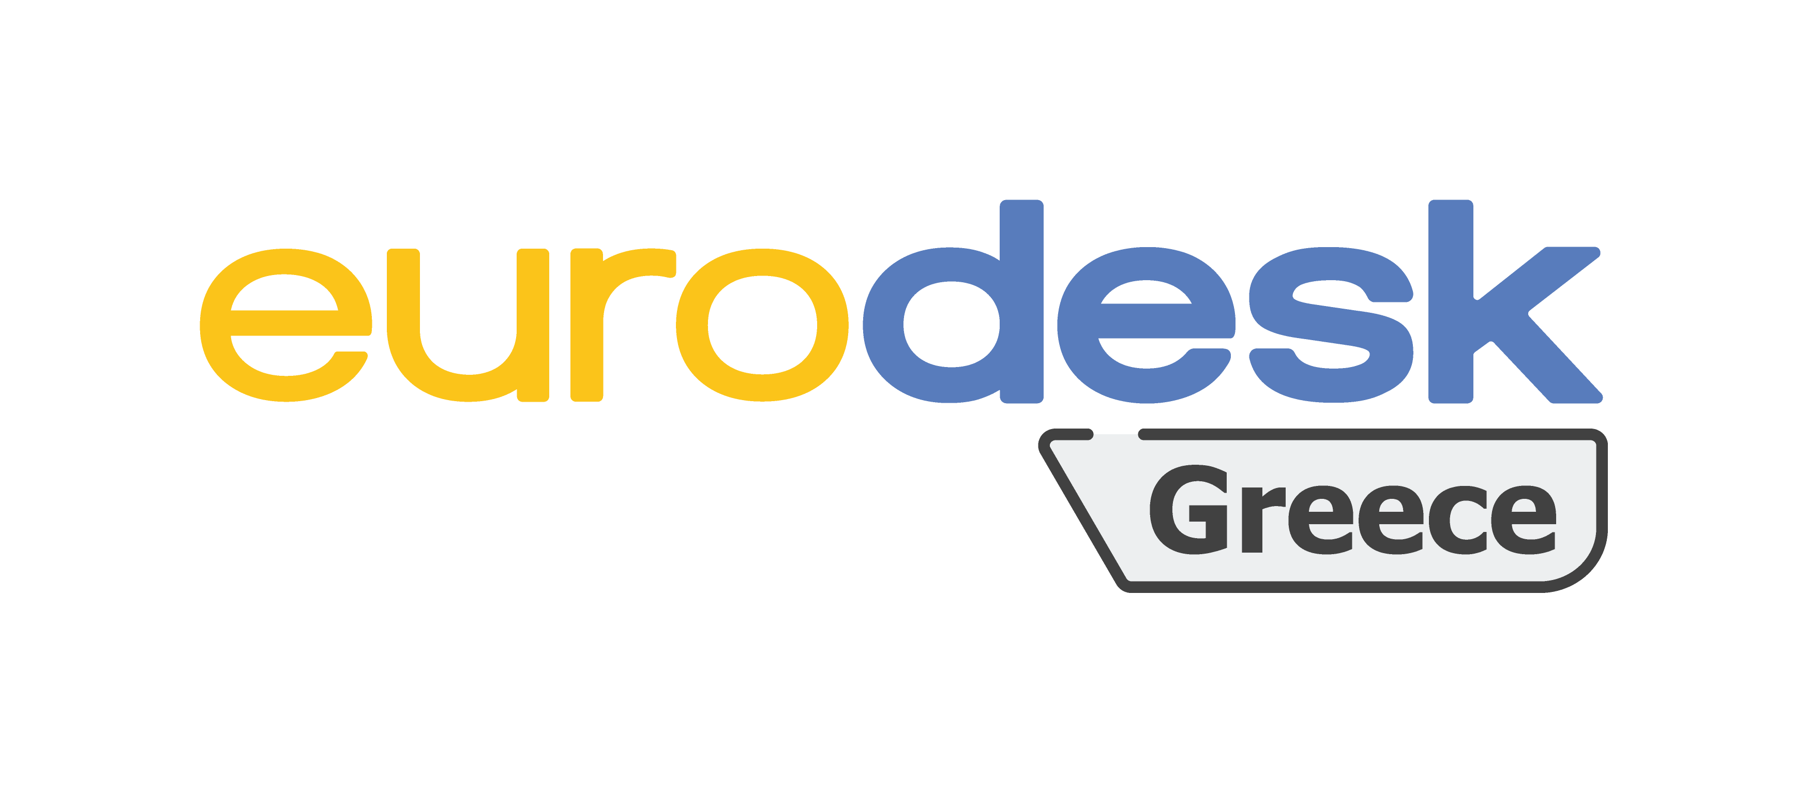

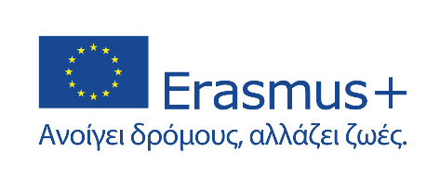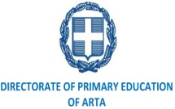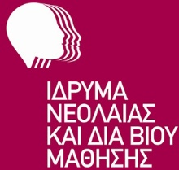
P R E S S R E L E A S E

The Directorate of Primary Education of Arta holds the position of multiplier Eurodesk, a European network with information structures in 36 countries and with more than 1,500 national, local, and regional partners.

In this context, the Directorate of Primary Education of Arta successfully organized the first half-day at the Chamber of Arta on 11-18-2022, Friday at 10.00΄a.m. A meeting where the first update was made on the activity "Time to move 4 all", regarding youth mobility opportunities, the youth card, the youthpass and eurodesk data management, representation, and communication issues.

After the warm welcome from the Director of DIPE Artas, Mrs Kleopatra Vasileiou and the Deputy Head of the Finance Department of DIPE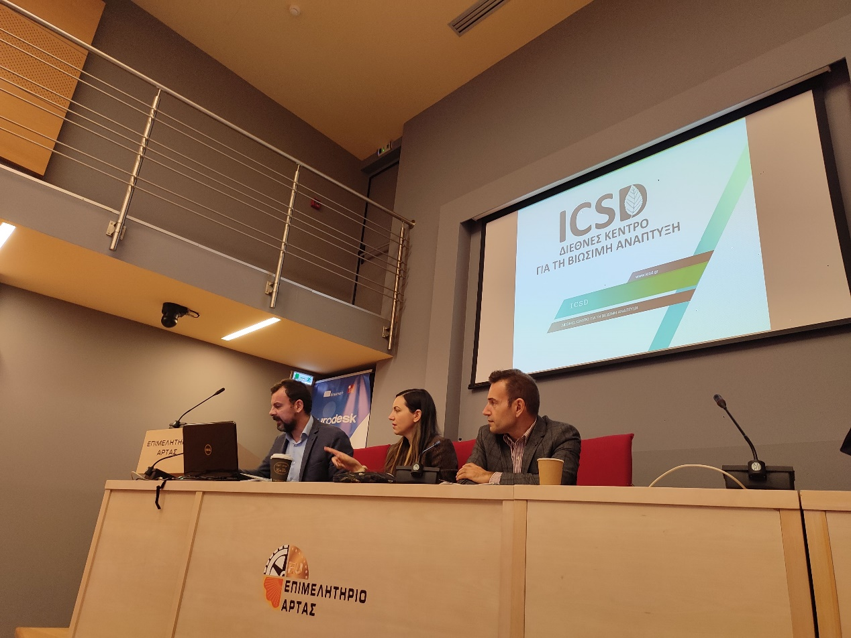 Artas, Mr. Nikolaos Skedos, the chosen guests took the floor:
- Kalliopi Dalla, National Coordinator of the Eurodesk Network, who made a short presentation of the Eurodesk Network and then talked about how to obtain the Youthpass Certificate, as well as the free youth cards, which are granted to people aged 13-30.
- Stefanos Panakoulias, President of the International Center for Sustainable Development (ICSD), who made a short presentation on youth mobility, as well as the volunteering program, in which young people participate and which is implemented within the framework of the European Solidarity Corps.

At the end, three (3) youth cards were given, as a gift of the European Eurodesk Network, to the attending students by the National Coordinator, Kalliopi Dalla.

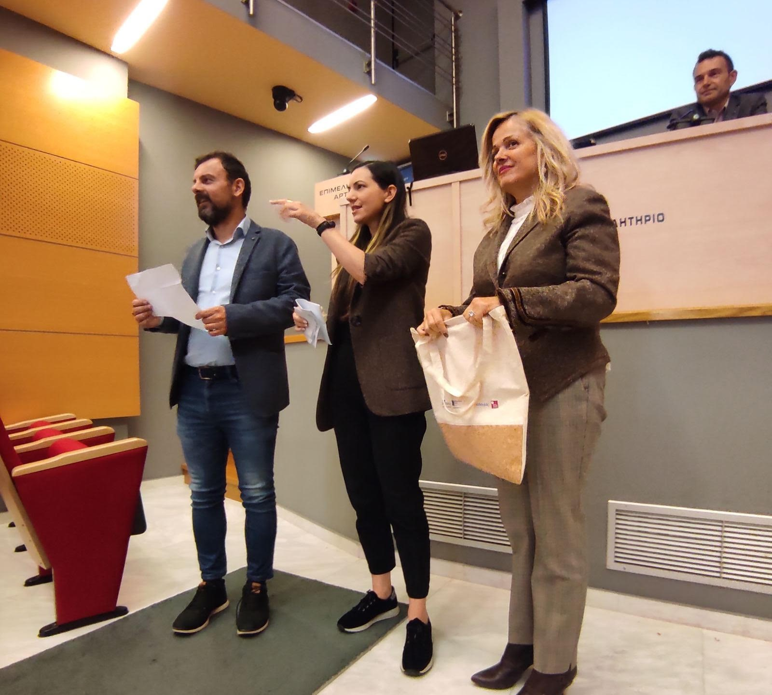

For DIPE Artas, Dr. Kleopatra N. Vasileiou

